March 3, 2023, TEGE EO Council Meeting
EO Update Session with TEGE Exempt Organization Division’s Rob Malone (Division Director) and Tim Berger (Senior Advisor to the Director), Moderated by Anne Fulton and Preston Quesenberry
Session’s Sections | TOPIC
 | Introduction of IRS Panelists and Moderators
Opening Remarks | Remarks from the IRS’s EO Division Director
Topic #1 | Business Master File Data Issues  - As of 3/2/23, if EOBMF is now updated through 2/14/23. However, as of 2/17/23, the EOBMF webpage (Exempt Organizations Business Master File Extract (EO BMF) has a last data post date of 11/14/2022 [that webpage was lasted updated 1/12/2023]. Can you please address what led to the delay and/or failure to post monthly data in December and January?  - Name changes-- we’d like to walk through several parts of IRM 21.3.8.9.2 (last updated 10-01-2022) which addresses how EOs may effect a name change [note: this is NOT about correcting errors in the IRS’s reporting of the organization’s name]. Our specific questions are:  - IRM at “2” states that filers who are req’d to file an annual information and who have not already notified the IRS of their name change “can report the change on their return according to the 990 instructions.” You noted this as well at Nov 18 meeting – but we understood from your comments then that this does NOT effect the change being entered on the BMF – is that correct?  - IRM at “3” states that organizations NOT required to file annual return (other than 990-N) and organizations who want a letter acknowledging the name change should provide documentation to specific enumerated IRS offices (in the case of organizations with an INDIVIDUAL ruling , i.e., not a central group ruling holder or subordinate of one, or other certain organiations without an individual ruling that would be the EO Correspondence Unit (fax number 855-204-6184)). Can you confirm that this is required to effect a change in the BMF? Is it the case that such a submission will generate a requested letter back from this Unit acknowledging the name change to filers who file Forms 990? And same question, but for 990-N filers?  - There is an exception at “3” for those filing delinquent Form 990 series returns – these must include the name change documentation with those filings rather than sending the name change information under separate cover. Previously you said that doing so will NOT effect a change in the BMF. Is that still accurate? How are the circumstance of these filers handled (and how do they differ from those addressed in IRM at “2” (see 1. above))?  - We continue to see issues of the IRS using old addresses when a taxpayer has submitted Form 8822-B multiple times and checked the “change of address” box on Form 990. Is there anything else an organization can/should do so that correspondence from the IRS is sent to the current address? (Mail forwarding generally only lasts 1 year.)
Topic #1 Prepared Remarks/Dialogue | Business Master File Data Issues
Topic #2 | E-filing and Form 4720 Matters  - A CCH Software News report released on 12/16/2022 [note: same is provided in Handouts] alerted customers and taxpayers of a systems issues regarding Forms 990/990-T Inclusion of Forms for Electronic Filing. Per the report: “When a 990/990-EZ/990-PF and a 990-T were exported from the same return for tax year 2021, forms might not have been included with the electronic file. […] If a return needs to be corrected, an amended return will need to be filed.” Is the IRS aware of this CCH systems issue and will the IRS release any specific guidance to indicate to taxpayers how to file their amended returns? Should any specific information be included in a cover letter with the amended return filing?  - When software issues such as the above arise due to software vendor limitations, what is the best practice to alert the IRS?  - Current IRS guidance indicates that that the IRS allows taxpayers to use electronic or digital signatures on certain paper forms through October 31, 2023. This leaves a gap for exempt organizations from November 1, 2023-November 15, 2023, when a high volume of organizations are filing returns.  - Will taxpayers be allowed to used electronic signatures for filing the Form 8879-TEs for 2022 Forms 990-EZ, 990 and 990-T? Has the IRS considered adopting electronic signatures as PERMANENT vs. temporary?  - See Details on using e-signatures for certain forms | Internal Revenue Service (irs.gov)  - Many tax-exempt organizations are required to file certain forms to report international activity (e.g. Forms 5471, 8865, 926, 8858). These forms are attached to the Form 990 or 990-T to be transmitted to the IRS. Can you please provide clear written guidance as to whether these forms must be e-filed via XML with the Form 990/990-T XML package, or whether the IRS will accept these forms in a PDF version attached to the e-file package?  - We were made aware that the Form 990-N filing system has been down for over a month as of 2/23/23. Many CPAs noted this to us late January (at which time a flag was on the webpage saying the system was down). That flag was removed as of 2/3/2023, but we heard from an experienced EO lawyer earlier this week that she has been trying to file a Form 990-N for over a month and every single time receives a message that an error has occurred prior to her even being able to locate the EIN of the entity. We understand that Publication 5248 was to be updated on or about 2/10/2023, and see that same has not yet occurred. Can you provide any update on the 990-N filing system?
Topic #2 Prepared Remarks/Dialogue | E-filing Issues
Topic #3 | Group Exemption Holders and Subordinates  (a) RESERVED (See question that was moved to the Appendix for Treasury/CC (EEE).)  (b) Issues with EOBMF coding relating to subordinate organizations  - Currently, in the BMF for a subordinate organization, the IRS (usually) puts the name of the group exemption letter holder in column B which is otherwise typically reserved for the name of the exempt entity with the subordinate organization’s name being placed in column AB. This has resulted in almost every database that pulls data from the IRS BMF Including TEOS incorrectly listing the group exemption holder’s name as the subordinate organization’s name. This causes issues with verifying exemption status with donors, especially with large-scale donors such as Cybergrants, the Blackbaud Giving Fund, and similar organizations. While they can be directed to IRS Pub 4573 about relying on the central organization in our experience when confronted with conflicting data from the IRS and a group exemption holder, these organizations will typically prefer to use IRS data. Would the IRS be willing to consider listing the name of the subordinate organization in Column B of the BMF and moving the central organization to column AB?  - Group Exemption Letter holders are required to submit information about their subordinate organizations annually to maintain the letter in force. In our experience, the IRS only acknowledges receipt of this information about half of the time, and usually only after any information changes are added to the BMF which tends to be several months after submission. Is there any good way to verify that the IRS has received the required annual information?  - Subordinate organizations with some frequency erroneously file 990-N’s in the name of the central organization. The central organization will then typically file its own 990 properly and face no consequences however it does make TEOS look like a mess. What is the best way for a central organization to have erroneously filed 990-Ns removed from its TEOS listing?  (c) Annual Information Report/BMF Accuracy Issues.  - The IRS currently provides little guidance on the formatting or delivery of the required annual information from group letter holders. However, to our knowledge, the only two ways to submit that information are by fax or by mail, with fax generally being a vastly more effective mechanism despite not being truly trackable. The result however is that the IRS will receive a paper copy of in our case hundreds or even thousands of changes to the IRS BMF. While this is a vast improvement of the previous method of hand-correcting a printed list, it still requires the IRS to somehow input these changes back into its system.  - It is our experience that the IRS’s accuracy with these updates is spotty. As one small example as of January 1/23/2023, a group exemption with approximately 4,800 subordinate organizations sees 811 errors in the BMF for its subordinate organizations. The vast majority of these are the incorrect name or address of the organization. Notably, however, not all of the errors appear to be simple typographical errors (such as dropping the “C” from “INC”) but can be as severe as changing the word “USA” to “CLUB” or not including “INC” at the end of the name. In addition, 68 organizations are listed with the wrong accounting period which causes tremendous issues when trying to file the 990 which typically cannot be resolved by calling the IRS, instead requiring going through the process of changing an organization’s fiscal year. Two organizations are also listed as having the wrong Group Exemption Number, and of greatest concern, two are listed with the wrong deductibility code making it appear that donations to them are not tax deductible.  Comments? We want to make the the IRS aware of these issues if it does not already have same in its sights. Can alternative methods of submission be employed to effect more efficient and accurate annual updating, or to make corrections?
Topic #3 Prepared Remarks/Dialogue | Group Exemptions – Feedback
Topic #4 | Other Issues  - The “Where’s My Application” page still says that after submitting the application you will receive an acknowledgement notice. Is this still the IRS protocol to send an acknowledgement notice? If not, can you please update the text on the website?  See Where's My Application for Tax-Exempt Status? | Internal Revenue Service (irs.gov)  “After submitting your application for tax-exempt status, you will receive an acknowledgement notice, which means the IRS has received your application.”  - Since early COVID, external entities that make 990s available (such as Candid.’s Guidestar site) do not generally seem to have access to 2020 Forms 990 (and to a lesser extend, 2019 Forms 990) for many entities. Can you discuss the reasons for the delays in those returns being available and note when those delayed returns will start to be released?  - The absence of Forms 990 makes it much more difficult for the sector and its overseers to conduct due diligence. For example, nonprofits that have filed their 990s on time are now unfairly suspected of being out of compliance because the IRS has failed to post their tax forms, and fundraising is impeded when donors don't have access to the most recently filed information. The lack of timely and consistent 990 data posted by the IRS was raised as an operational concern in the 2022 IRS Advisory Council report. Please let the field know when machine-readable 990 data links for 2021/2022 will be available to the public, and whether you are taking any steps to address the operational improvements called for by the IRS Advisory Council? Publication 5316 (Rev. 11-2022) (irs.gov) (pages 102-103)  - IRS I.T. improvements anticipated from Inflation Reduction Act funding we have heard will allow 26 separate systems now run with COBOL programming to migrate to new program language. Is the Business Master File one of those? Are there separate exempt organization systems aside from BMF in that count? How integrated is the Business Master File data of exempt organizations in larger IRS system?  - The retroactive-to-date of formation “rule” that mandates 501(c)(3) applicants must file exemption application by end of 27 month post-formation can be waived via available IRC sec. 9100 relief. For non-501(c)(3)s, a “rule” disallowing retroactive-to-formation ruling for those who file for exemption after end of 27 months post-formation was effected in recent years via the annual Rev. Procedures. Non-c3 organizations who seek a reasonable cause waiver which would thus allow retroactive exemption to date of formation have been informed by Determs’ staff that the absence of a statute allowing relief from the rule bars the IRS from considering waiver requests. That sets up a catch-22: Treasury via administrative procedures has set an inviolate rule that only Congress can address.  - Lack of data on EO sector’s number of returns in process exists in many cases because tax filings have no coding that identifies filer as a tax-exempt entity – for example, Form 941x does not reflect taxable vs. tax-exempt status of filing org. Are other mechanisms available by which IRS can readily detail number of ERC pending claims from 501(c)-filers? (other arenas where such data would be helpful could be added too)  - Late filing penalties are still being assessed on delinquent 990s filed as part of the organization’s efforts to reestablish exempt status after auto-revocation even with filers inputting reference to Revenue Procedure 2014-11 on page 1 of each delinquent return. Penalty assessments still coming and some penalty abatement requests have been before IRS staff who state they are not familiar with retroactive reinstatement procedures. For e-filed returns, we are concerned that perhaps the designation on page 1 is not being transmitted properly and/or being entered into the IRS computer systems. Can you please comment?  - We continue to see errors stemming from filing 990s for the three consecutive years that caused automatic revocation (these are to be filed via paper submission to perfect a retroactive reinstatement application under Rev. Proc. 2014-11). What steps should a taxpayer take if they receive late filing assessments? How can a taxpayer request penalty abatement?  - RESERVED  - The 2022 instructions for Forms 990, 990-EZ, and 990-PF no longer provide the “Table of Contents” list that has in prior years appeared on the instructions’ page 1. This makes it very difficult to quickly navigate to the desired page in the instructions. We hope that this omission is temporary and can be restored (at least for future years); we also hope that the Contents list will remain and not be removed them from the 2022 Form 990-T instructions (they appear on the draft 2022 990-T instructions).
Topic #4 Prepared Remarks/Dialogue | Other/Misc – Feedback

Ancillary Information Augmenting Agenda Topics

TOPIC 1 (at (a)): 1/30/2023 screenshot of https://www.irs.gov/charities-non-profits/tax-exempt-organization-search-bulk-data-downloads, below, shows Pub. 78 data, auto-revoked list, and Form 990-N postcard filings having last been updated in September, and Form 990-series filings having last been updated in August. However, several of the link-accessed data files appear to be dated January 2023 (and search of auto-revocation does show groups with January 2023 published revocations).
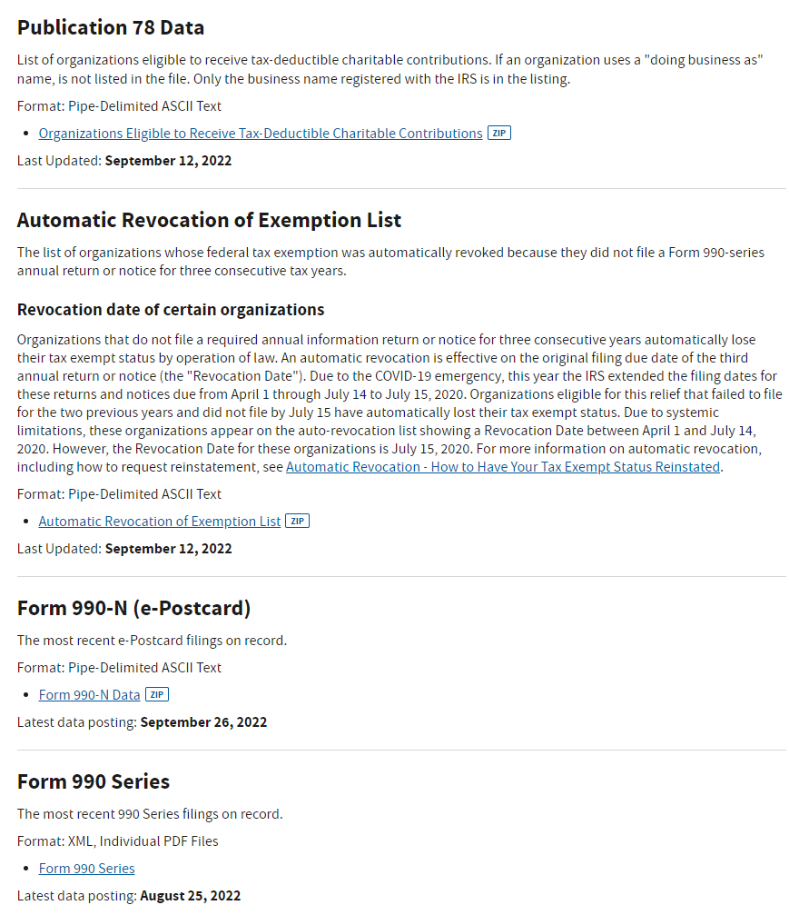

The webpage cited in the agenda, “Exempt Organizations Business Master File Extract (EOBMF)” is where users may download cumulative files with data from the most recent information the IRS has for these organizations. As the agenda noted, the “updated date posting date” shown at 1/30/2023 was 11/14/2022. That webpage is excerpted in pertinent part on the following page.

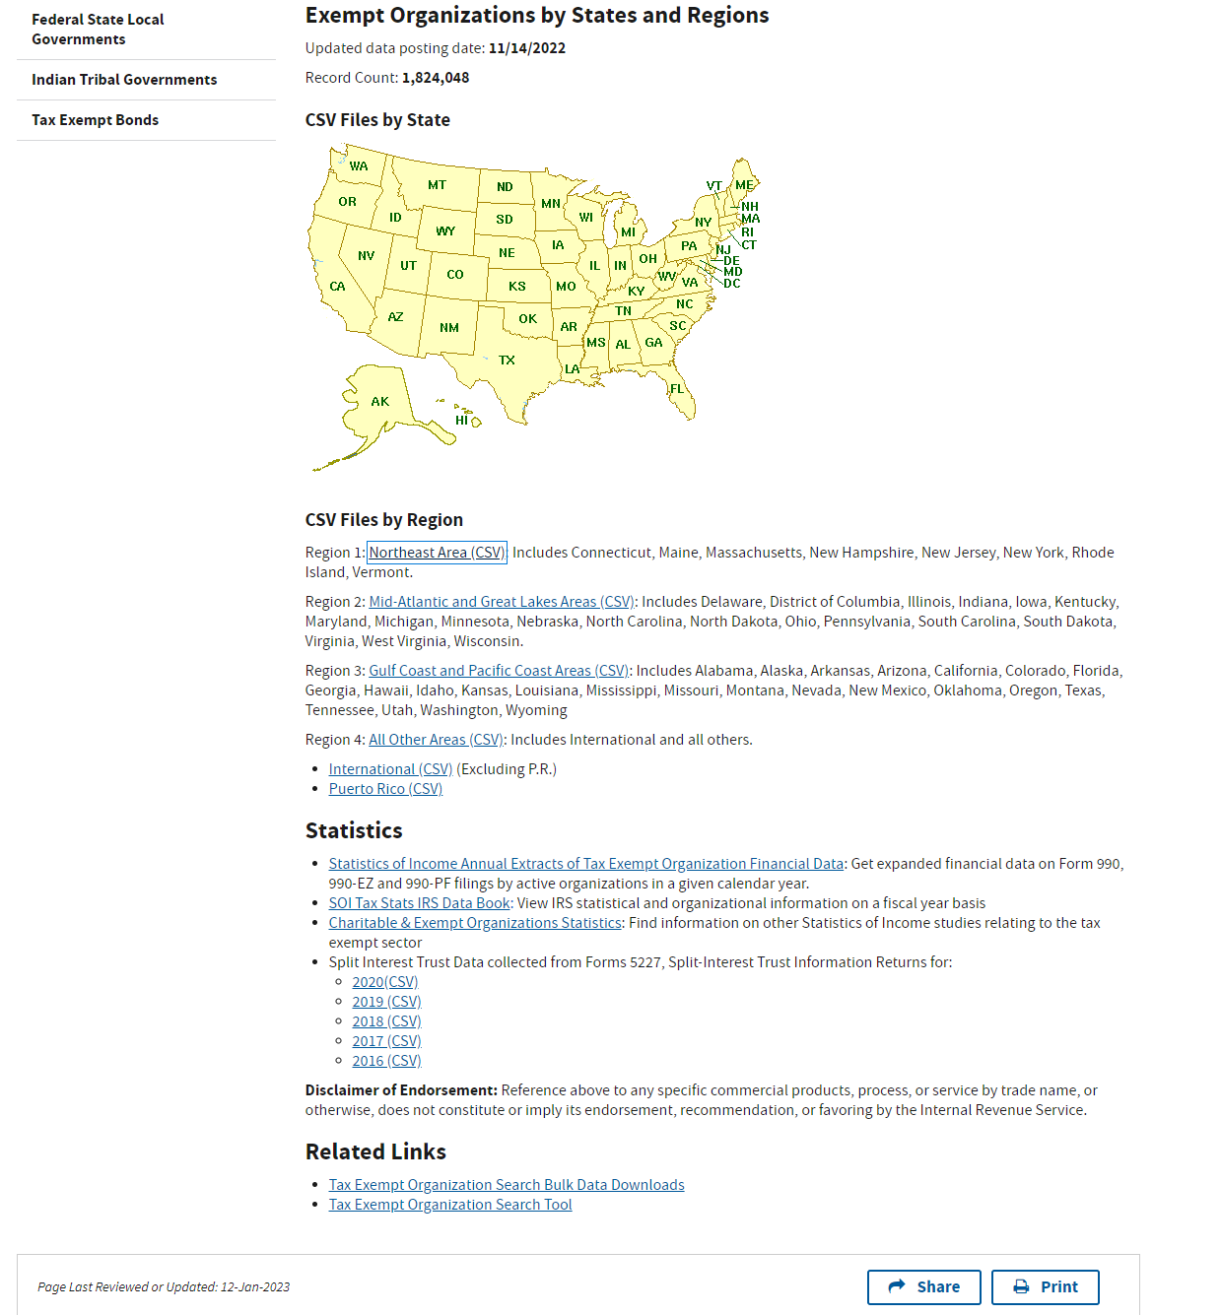

Topic 2 (at (a)): CCH Software News - 990/990-T Inclusion of Forms for Electronic Filing, available at: https://prosystemfxsupport.tax.cchgroup.com/issues.nsf/214a6a52ab33ce9b862576d200747222/36f14579c969a97a8625891a006dce56?OpenDocument

Topic 3 (at (a)):
In 2020 the IRS issued proposed updated revenue procedures under which recognition of exemption from federal income tax for organizations described in Section 501(c) of the Internal Revenue Code may be obtained on a group basis for subordinate organizations affiliated with and under the general supervision or control of a central organization. Beginning on June 17, 2020, the IRS stopped accepting requests for group exemption letters. It would be helpful for taxpayers interested in group exemptions to have a better idea of when it will be possible to apply for a group exemption so they may better weigh waiting for the new procedures against the logistics of filing exemption applications for organizations that would have been a subordinate in a group exemption separately. We also have the following specific queries:
- Does the IRS still intend to have a “matching requirement” in their updated procedures?
- Does the IRS still intend to require subordinate 501(c)(3) organizations to have the same foundation status as the central organization?
- Does the IRS still intend to revoke group exemption letters where more than half of the subordinate organizations have been automatically revoked? If so how does the IRS intend to track that statistic given that subordinate organizations that have been revoked can be subsequently removed from the group exemption via the required information required to be submitted to maintain the group exemption?

Topic 4 (at (b)): According to Candid’s September 2022 analysis, tens of thousands of 2019 and 30% of 2020 Form 990s have yet to be posted; delays are considerably worse for Form 990-PFs (only 76% of 990-PFs from 2019 have been posted).
Refer to Publication 5316 (Rev. 11-2022) (irs.gov) (pages 102-103)
Form 4720 Issues with E-filing January 2023 and Prior: Updates

From the TIC TAQ Committee:
For the last two filing seasons, exempt organizations filing Form 4720 to report an excess benefit transaction under IRC section 4958 or private foundations filing Form 4720 to report acts of self-dealing under IRC section 4941 initially had been the subject of collection efforts, which sought to collect the amount of excise tax liability that would be the responsibility of the subject disqualified person from the organization. This issue was addressed at both the EO Update sessions held June and November 2022. The IRS’s Exempt Organization Division in both sessions stated that the issue was caused by filers incorrectly completing Form 4720 Part I and Part II by failing to report $-0- tax payable there.
Since the November EO Update session, filers have had properly completed Forms 4720 filed in November and December returned to them even though the filed forms had been prepared correctly (showing no tax due or payable on the part of the filer). This development was brought to the attention of the Division’s Director, Robert Malone, and Senior Technical Advisor, Timothy Berger,in early January by the Committee and Berger escalated the issue for further internal review. The result noted to us mid-January was that the returned filings occurred due to an issue on the IRS’s end. They thus advised as follows:
If an organization or private foundation is filing a Form 4720 to report an excess benefit transaction or act of self-dealing of a disqualified person, please hold off electronically the return until January 25, 2023 or later. Otherwise, the Form 4720 may be returned to the entity, as the IRS cannot currently process the return when there is zero tax reported on Part I or II of the Form 4720 (which is appropriate for such a filing). The IRS is updating its systems and IRM provision 3.11.12.11.1(5) in order to resolve the issue.
The Committee expresses our gratitude to Tim Berger and Robert Malone for their efforts and connecting with IRS teams to resolve this issue.

For further information on how to correctly fill out Form 4720, please refer to the transcript from the IRS’s Charities & Tax-Exempt Organization Update presented by IRS tax law specialists Elaine Leichter and John Matias on August 16, 2022: https://www.irstaxforumsonline.com/sites/default/files/players/4cte722/downloads/4cte722transcript.pdf.)

